**LAB MANUAL 6**

# LAB TASK :

## TASK 1 :

CODE :

#include<iostream>

using namespace std;

int main(){

int x;

cout<<"enter the number of terms:";

cin>>x;

int a=0, b=1;

for (int i=0; i<x; i++){

cout<<a;

int sum=a;

a=b;

b= sum + a;

}

return 0;

}

OUTPUT :

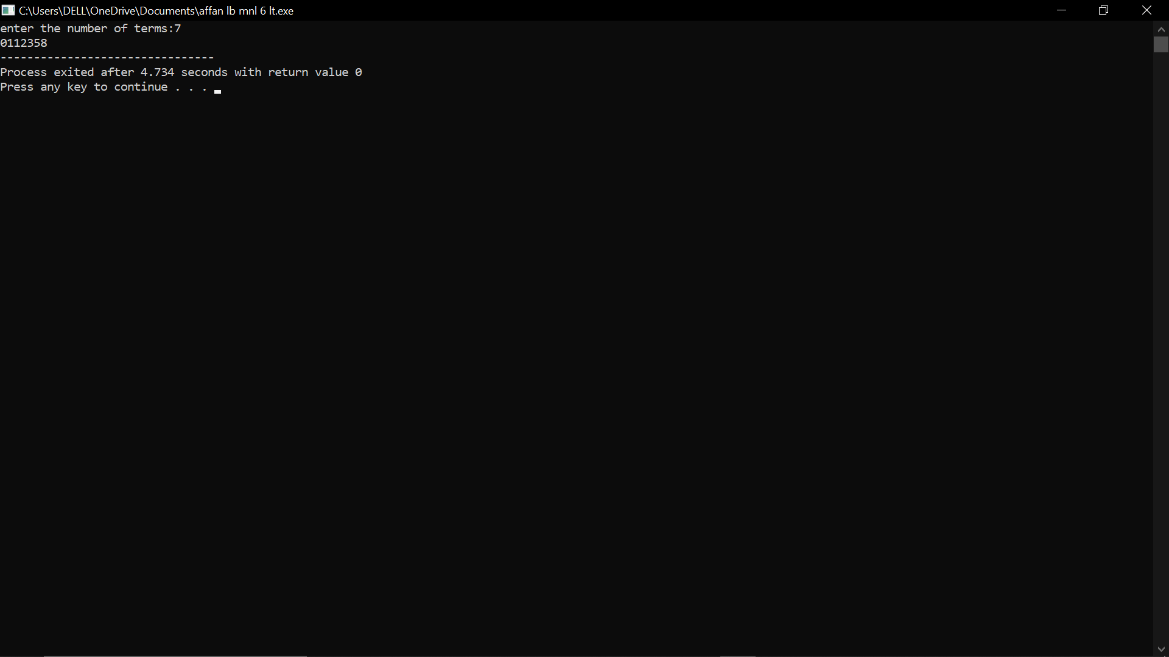

## TASK 2 :

CODE :

#include<iostream>

using namespace std;

int main(){

cout<<"enter number of rows:";

int num_rows;

cin>>num_rows;

for (int i = 0; i < num_rows; i++) {

int coefficient = 1;

for (int j = 0; j < num_rows - i - 1; j++) {

cout << " ";

}

for (int j = 0; j <= i; j++) {

cout << " " << coefficient;

coefficient = coefficient * (i - j) / (j + 1);

}

cout << endl;

}

return 0;

}

OUTPUT :

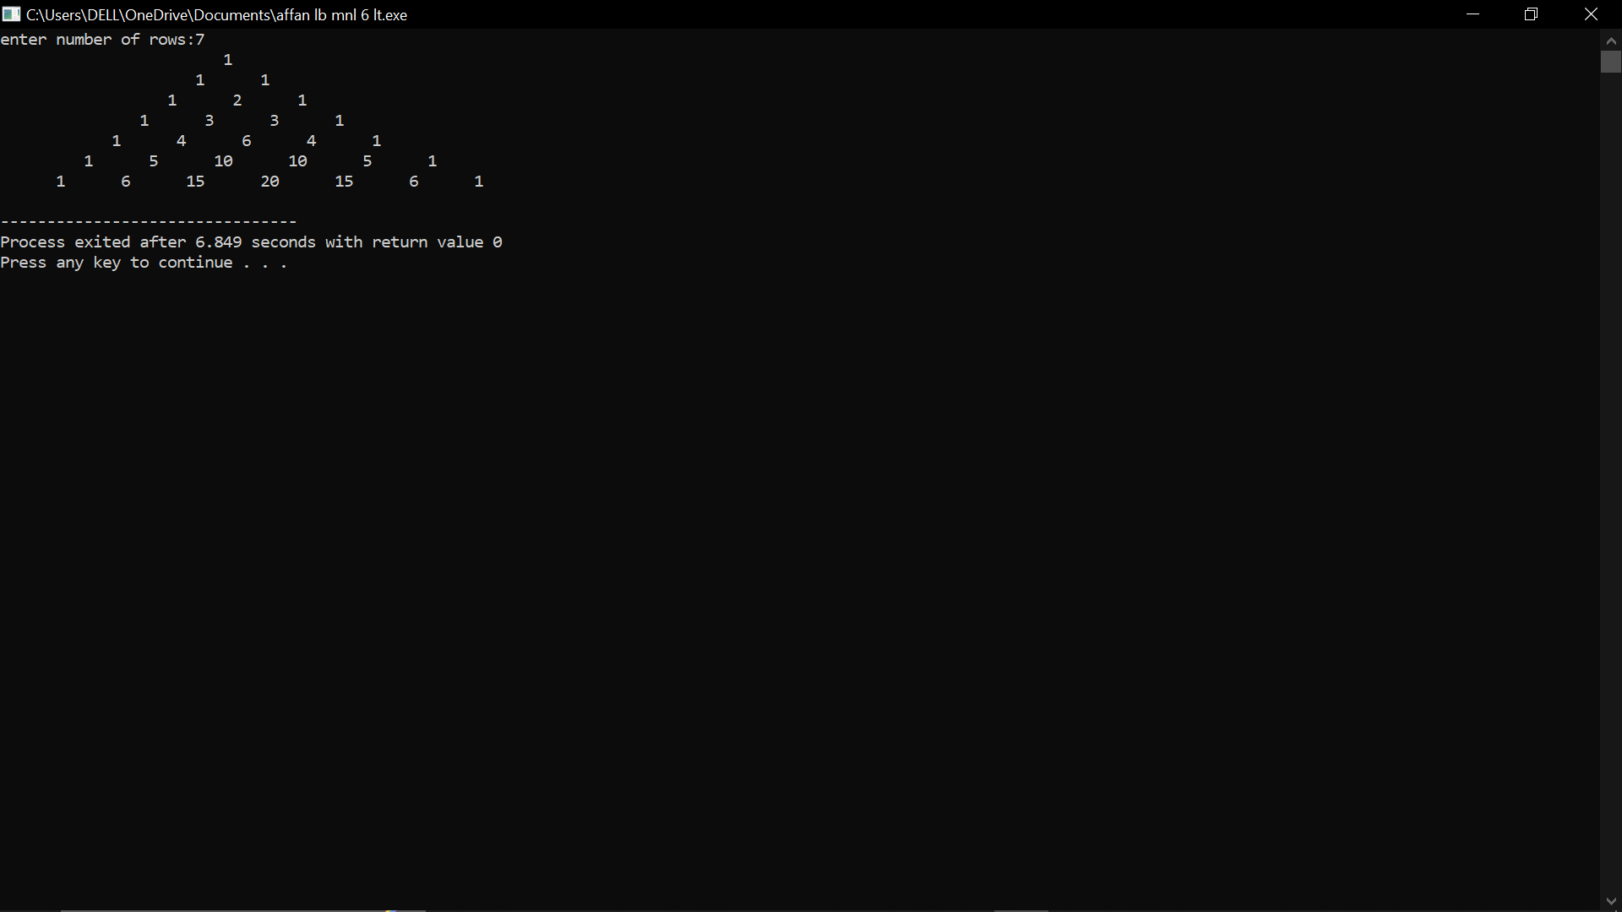

# HOME TASK :

## TASK 1 :

CODE :

#include<iostream>

using namespace std;

int main(){

int sum = 0;

for (int num = 2; num <= 50; num++) {

bool isPrime = true;

for (int i = 2; i <= num / 2; i++) {

if (num % i == 0) {

isPrime = false;

break;

}

}

if (isPrime) {

sum += num;

}

}

cout << "Sum of prime numbers from 1 to 50: " << sum << endl;

return 0;

}

OUTPUT :

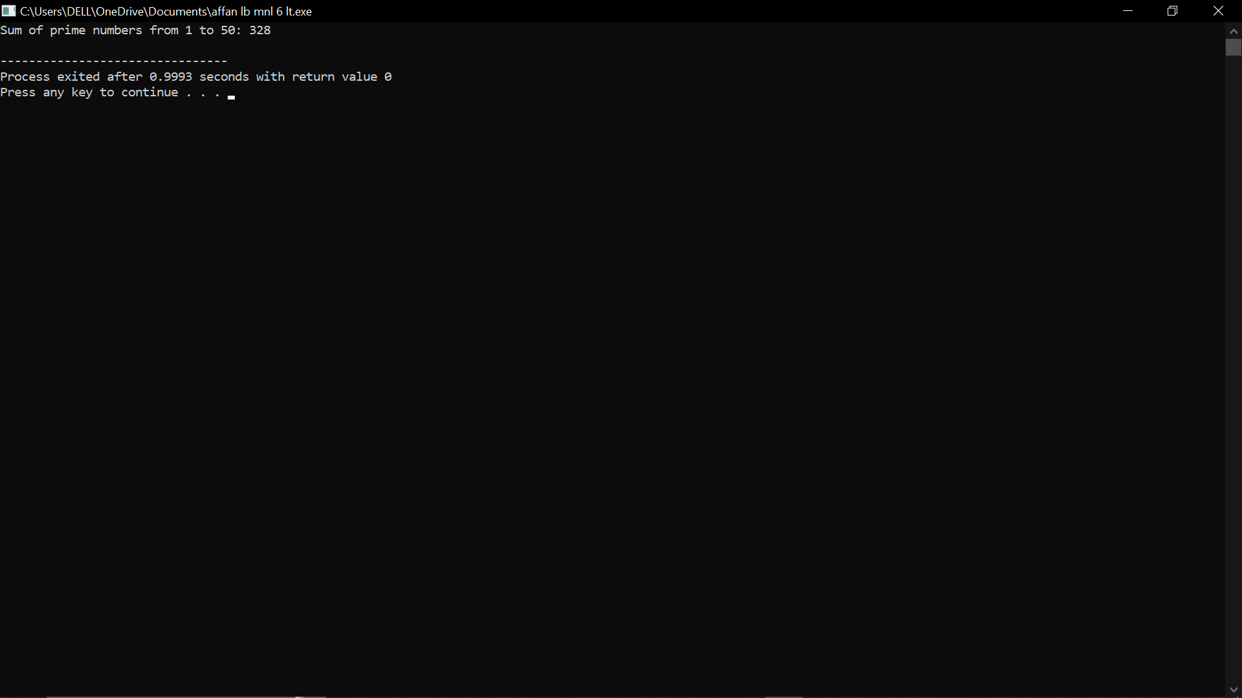

## TASK 2 :

CODE :

#include<iostream>

using namespace std;

int main(){

int rows = 5;

for (int i = 1; i <= rows; i++) {

for (int j = 1; j <= i; j++) {

cout << j << " ";

}

cout << endl;

}

return 0;

}

OUTPUT :

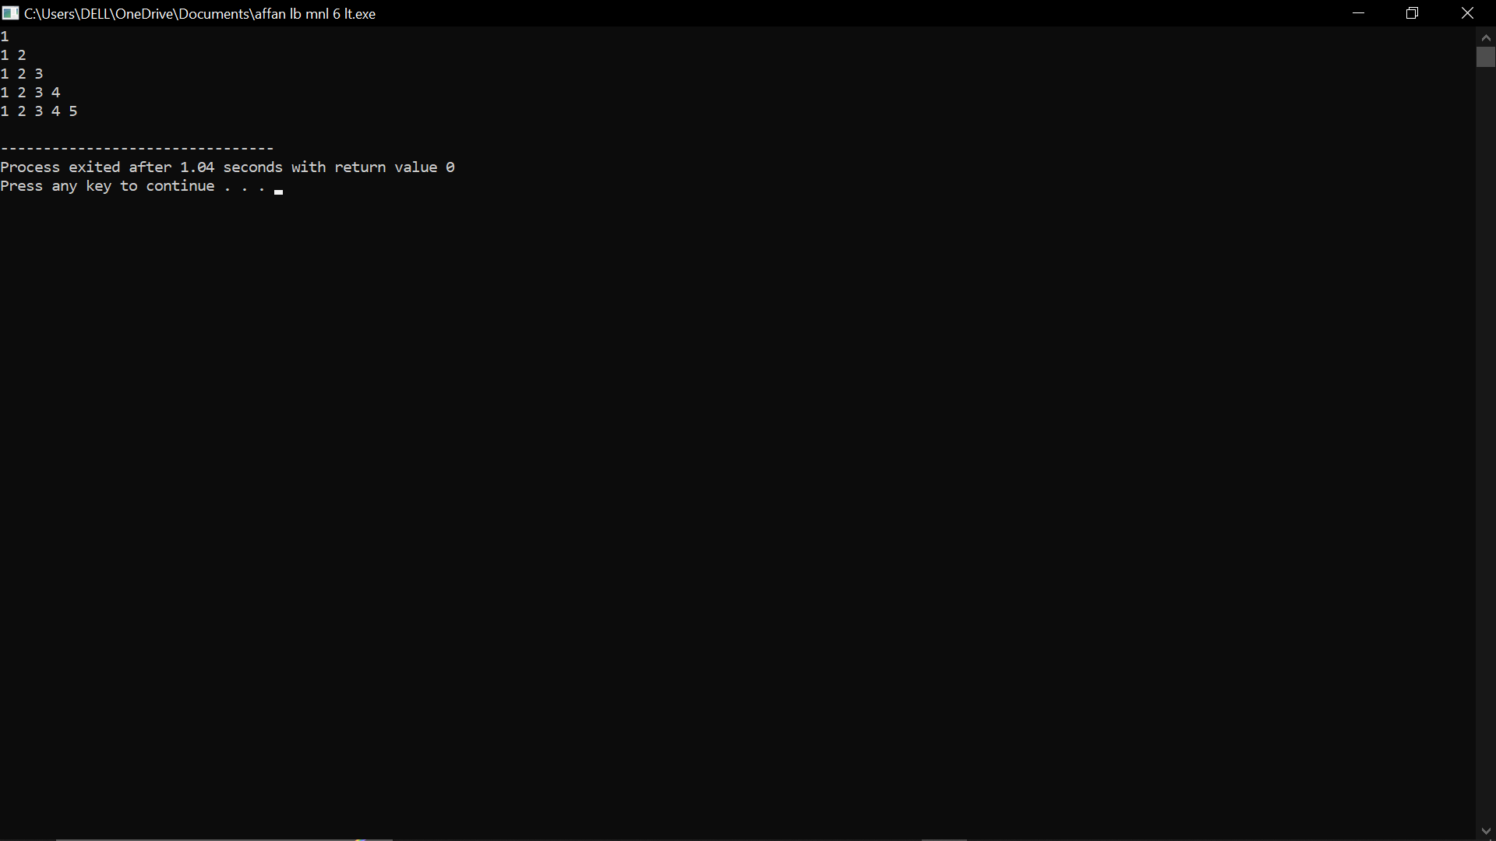

## TASK 3 :

CODE :

#include<iostream>

using namespace std;

int main()

{

int rows = 4;

for (int i = 0; i < rows; i++)

{

if (i == 0){

cout<<1;

}

Else

{

for (int j = 0; j < i*2 ; j++){

cout << i*2 << " ";

}

}

cout << endl;

}

return 0;

}

OUTPUT :

